Task 1 plan
Import any libraries needed. (Array, date, time)
Create a program save all variables from the text file
Create a subprogram for each of the sorts and searches (Quick sort, bubble sort, binary search, linear search).
Write a subprogram to read from an external text file and save all contents as a 2D array.
Write a program to take a user input with a vendor name, ensure the input is formatted to remove error with vendor names.
Create a while loop with an interface that the user can use to select what they would like to do (search, create, edit, display a list of all vendors, display the efficiency of the program)

VALIDATE ALL USER INPUTS
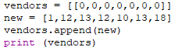
In this program, I experimented with appending a row to an array

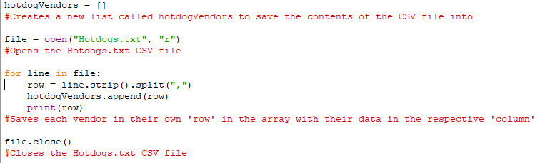
This is the V1 of my program, where I can open the Hotdogs.txt file and save it as an array.
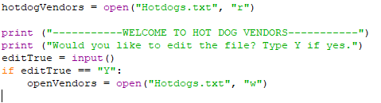
My first version of a User Interface in a separate python file.

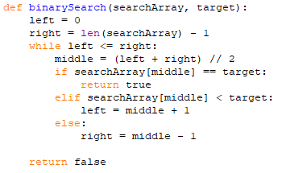
This is a binary search algorithm I programmed separately, and then integrated in to my main program.
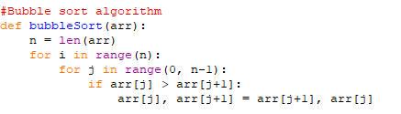
This is a bubble sort algorithm I integrated from an external python file.
This is my V2:
-Expanded user interface than in V1 (still not complete)
-Subroutines for Linear search, Binary search, Quick sort and Bubble sort

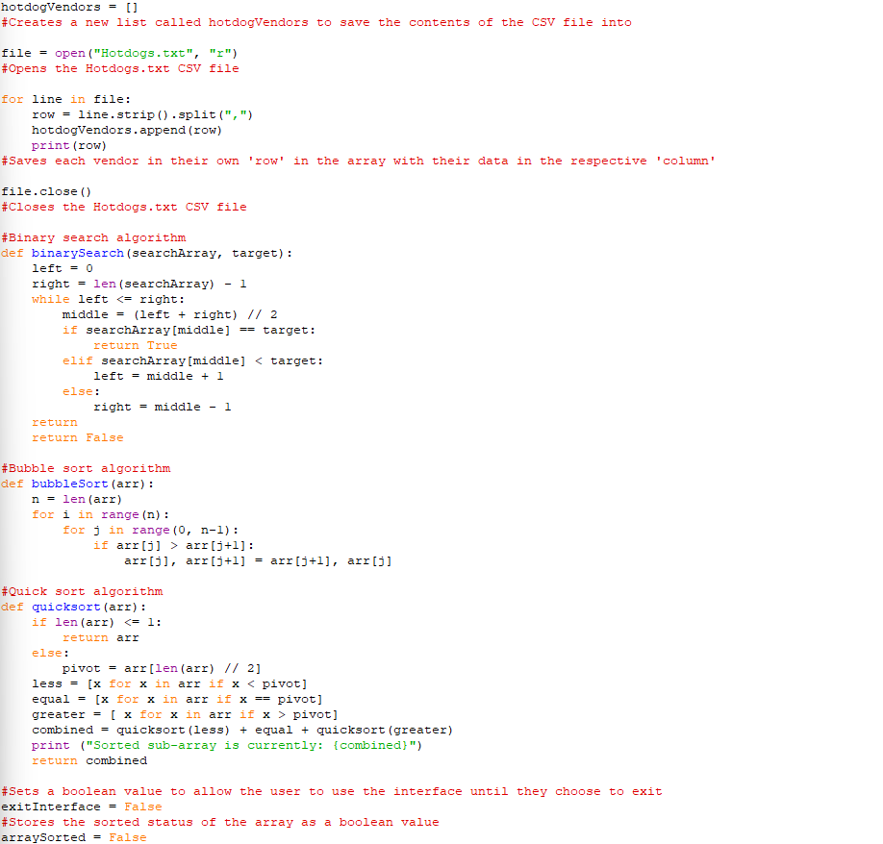
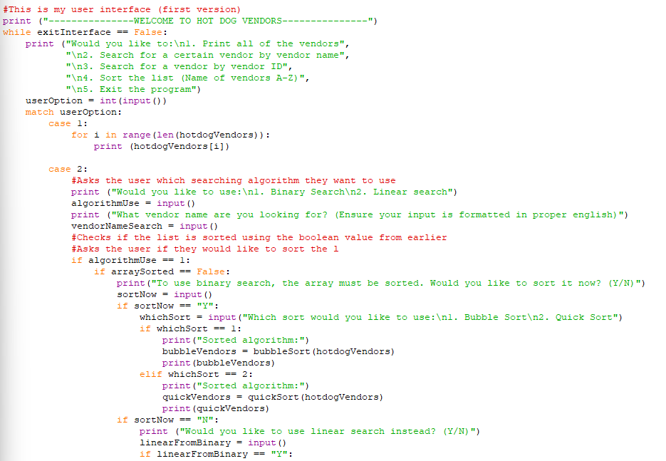
V3 of my program implemented a subroutine for validating all values in the array.

V7
My V7 focused on fixing all of my known problems so far. These included:
-Validating user input for the UI
-Linear search searching one column instead of all data (fair for efficiency compairsons)
Both algorithms were tested on the same dataset and column to ensure a fair comparison of efficiency.”
-Sorts saving the sorted data as a new list, but the new list is not used
-Ketchup validation was outside the loop
-Binary search inconsistent, sometimes searches unsorted data or includes the title row
-isdigit() not called correctly in the onions validation
-overall validation always returns true
I also added an option to edit existing vendor information
-Inefficient bubble sort loop

def editVendor(array):
print ("Enter the vendor ID and date of the vendor you would like to edit.")
vendorIDEdit = print ("Vendor ID:")
vendorDateEdit = print ("Vendor Date:")
findVendor = linear(hotdogVendors, vendorID)
specificVendor = linear(findVendor, vendorDateEdit)

